
uckland
chool
72 George Cres
RD2
PUKEKOHE

Tel: (09) 238 9419
Fax: (09) 238 9463
Email: principal@buckland.school.nz

Thank you for your interest in the full time permanent teaching position we now have available starting 2020. Please see NZ Education Gazette for advertisement.

Buckland School is situated between Pukekohe and Tuakau and is a U4 school of approximately 280 children. We are a Decile 8 school which caters for Years 1 – 8. We are fortunate to have excellent parental support.

Expectations are high and the school has a committed, forward-thinking staff who work as an effective team. Our children are a pleasure to teach and respond positively to the wide range of learning experiences we offer.

Staff are expected to be fully involved in all school activities and to work together with parents and the school community to provide the best education we can for the children in our care. Literacy, Mathematics and IT continue to be a focus for the school in 2020.

Attached are several forms we would like filled out with your application. Please forward a C.V., application form and state referees who can be contacted. Applications close at 4 p.m. on 18 November 2019. Please indicate your curriculum strengths and interested level.

Please do not hesitate to contact me if you would like further information.

Yours sincerely
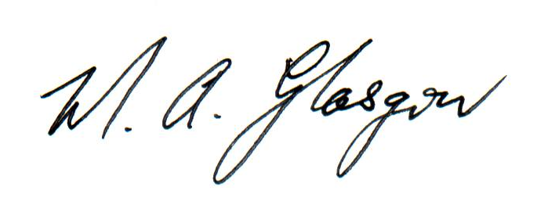

Mavis Glasgow
Principal

