ezlunch Thursday sushi lunch orders
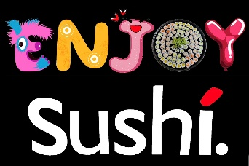
You can order your favourite sushi for a Thursday lunch while supporting our school. Simply place your order by clicking here!
You can order (or cancel) by 9am on the day of delivery or schedule in advance. Your lunch will be delivered to the school in time for lunch.
Click here to view the menu.
ezlunch orders are made online through your myKindo account. One account for the whole family! Get started now and be ready… Click here or go to www.mykindo.co.nz to start ordering!

for Apple and Android users
download the mykindo app.
Help? Visit support.mykindo.co.nz or tel. 475 5287 or 0800 EZLUNCH weekdays 8am-4pm.
www.mykindo.co.nz
www.ezlunch.co.nz

